Chinook Salmon Redd Survey Methods

Chinook Salmon redd surveys begin in mid-September at the onset of spawning and generally conclude at the end of November.

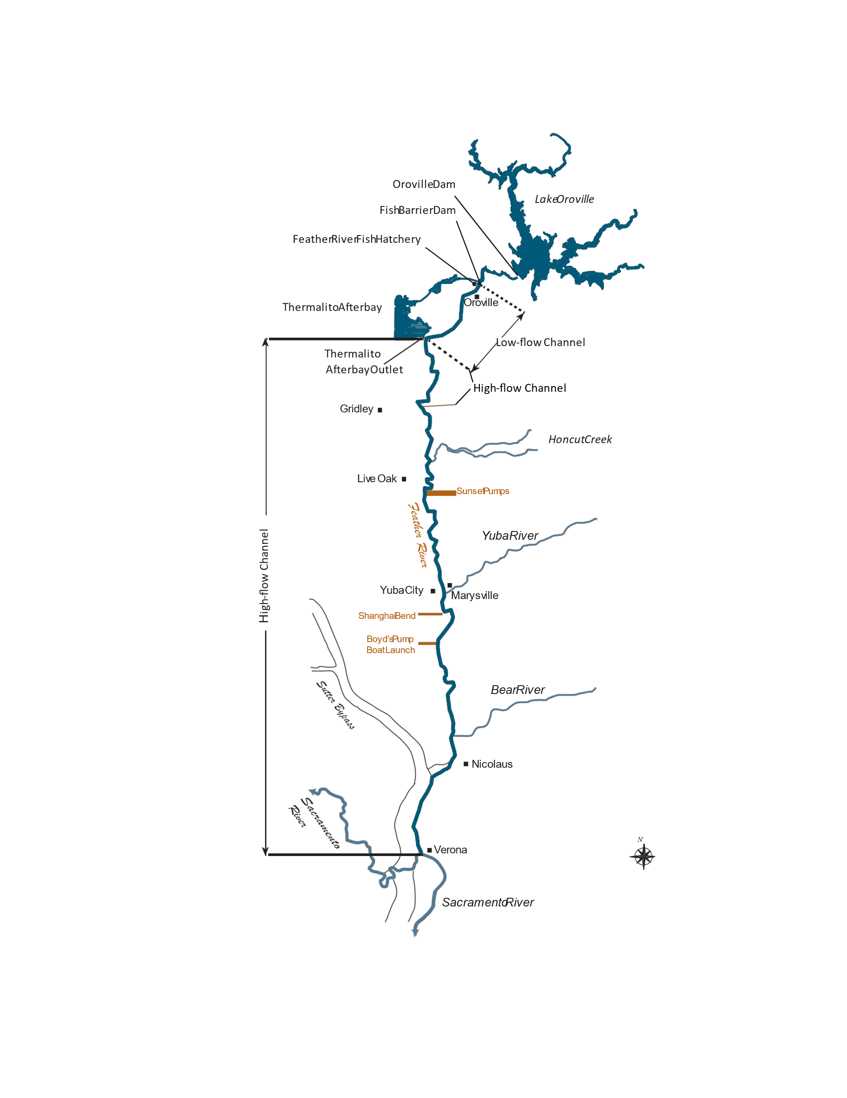The redd surveys are conducted in the uppermost 16 miles of the lower Feather River. Surveys extend from the Table Mountain Bridge in downtown Oroville, CA, downstream to the East Gridley Road Bridge near Gridley, CA (Figure 1). Since 2014, the Chinook salmon redd survey effort has been concentrated in the uppermost 2 miles of the low-flow channel (LFC) of the lower Feather River in, and adjacent to the Gravel Supplementation Areas (GSAs) (Figures 2,3, and 4). Redd surveys are also conducted, but less frequently, in the 14 miles downstream of the GSAs (Figures 5 and 6). The redd data from these locations can be used to quantify and understand potential shifts in redd distribution and to quantify potential physical habitat differences (size, substrate, etc.) between historic and restored sites.

**Figure 1**. Map of the lower Feather River

**Figure 1**. Map of the redd study area.

**Figure 2**. Map of Gravel Supplementation Areas and adjacent spawning areas near Feather River Fish Hatchery

**Figure 3**. Map of the uppermost Gravel Supplementation Areas near downtown Oroville, CA

**Figure 4**. Map of the lowermost Gravel Supplementation Area adjacent to Bedrock Park in downtown Oroville, CA.

One of the goals for the redd survey every year is to inspect the entirety of the GSAs and all adjacent spawning areas multiple times each survey week for newly developed redds. Surveys in and adjacent to the GSAs are suspended when it is no longer possible to distinguish new redds due to superimposition. For this reason, the duration of the survey period in the GSAs can change between years.

Redd mapping in spawning areas outside of the GSAs is primarily used to provide annual spatial and temporal spawning information and to inform future gravel enhancement projects. These locations are less heavily utilized for spawning than the GSAs. As such these locations can be mapped less frequently than those in and adjacent to the GSAs. Survey locations downstream of the GSAs are mapped weekly or every other week depending on the amount of time needed to perform multiple surveys per week in the GSAs (Figure 5). Redd surveys conducted in the high-flow channel (HFC) (Figure 6) are also used to provide spatial and temporal spawning information but can be used to investigate the potential for redd dewatering when flows reductions occur in the HFC. In some years, some spawning locations outside of the GSAs may not be mapped. A metadata statement for each annual redd survey is included below.

Visual redd surveys are performed by a crew of two staff members wearing polarized sunglasses. The crew members thoroughly search each survey location looking for newly developed redds. A boat is used to locate and position surveyors over redds in deeper sections (>3 ft) of the river where wading is not possible. Only completed redds, identified by a pot and tail spill, are marked and counted. Test redds, those without a complete pot and tail spill, are not marked. Survey locations within the GSAs and adjacent spawning areas without redds are not reported in the record, only those locations with redds are reported.

Redds are recorded geospatially with a Trimble GeoXH 6000 handheld GPS utilizing virtual reference station real time position correction with accuracy of 10 cm or a Juniper Systems Mesa³ Rugged Tablet connected to a Geode GNS3M Multi-Frequency Antennae. A single point is recorded by placing the GPS antennae over the center of the redd pot to record its location (Redd Point).

Depth, velocity, and substrate data is recorded on every fifth or tenth redd based on time constraints during each survey. Substrate composition is recorded by visually estimating the percentage of five substrate size categories: Fines (< 1cm), Gravel (1-5 cm), Cobble (6-15 cm), Large Cobble (16-30 cm), and Boulder (> 30 cm). Physical data (depth, velocity, and substrate) is not recorded for redds that are deeper than 3 feet and where a boat is necessary to collect position data. Depth measurements are recorded with a standard top-setting wading rod at the head and in the pot of the redd. Velocity readings are measured at 60% depth at the head of the redd with an Ott MF Pro flowmeter.

At locations where depth and velocity data are collected, the width and length are also measured at the widest and longest part of the redd to the nearest 0.1 meter. When individual redds are difficult to distinguish from one another (overlapping), no area measurements are collected.

After field data collection, information is downloaded and processed using Trimble GPS Pathfinder Office 3.10 or Juniper System’s Uinta software.

Microsoft Excel is used for statistical analysis and graphical representation of the data. ArcGIS Pro is used for spatial analysis.

**Figure 6**. Chinook Salmon spawning areas in the high-flow channel from the Thermalito Afterbay Outlet to Developing Riffle

**Yearly Chinook Salmon Redd Survey Summaries**

**2014-** Surveys began on September 9 and concluded on November 21 (9 survey weeks). In 2014, redd surveys were confined to the Gravel Supplementation Areas (GSAs) between Upper Cottonwood and Lower Auditorium (Figure 3). These areas were surveyed for redds twice a week during the first two weeks of the redd survey. All GSAs except Lower Auditorium were surveyed twice a week during weeks 3 and 4 of the survey (Figure 3). All GSAs located between Upper Cottonwood and Lower Auditorium were surveyed once a week during weeks 5 through 8 (Figure 3). Only Upper Hatchery, Upper Cottonwood, Cottonwood, and Top of Auditorium were surveyed during the final week 9 survey because it was too difficult to determine new redds due to superimposition at all the other gravel supplementation sites (Figure 3). No surveys were performed downstream of Lower Auditorium in the LFC in 2014 (Figure 5). Redd surveys were performed at spawning areas in the high-flow channel (HFC) on October 9 (week 5) and November 7 (week 8) (Figure 6).

**2015-** Surveys began on September 16 and concluded on December 4 (13 survey weeks). In 2015, redd surveys were confined to the Gravel Supplementation Areas (GSAs) between Upper Cottonwood and Lower Auditorium (Figure 3). These GSAs were surveyed for redds twice a week for the first 8 weeks of the redd survey except for week 5 where the GSAs were surveyed once due to time restrictions. The GSAs were surveyed once a week for the remainder of the redd survey season (Figure 2). Physical data was recorded for every redd during the first two weekly surveys then these data were recorded on every fifth redd beginning with the week 3 survey. No surveys were performed downstream of the Lower Auditorium in 2015 (Figure 5). Redd surveys were performed at spawning areas in the high-flow channel on October 16 (week 5),20,21(week 6) and November 19 (week 10), and December 3 (week 13). (Figure 6).

**2016-** Surveys began on September 20 and concluded on November 18 (9 survey weeks). In 2016, redd surveys were confined to the Gravel Supplementation Areas (GSAs) between Upper Cottonwood and Lower Auditorium (Figure 3). These GSAs were surveyed for redds once a week for the entire redd survey season (Figure 2). Physical data was recorded on every fifth redd for the first 3 weeks of the survey then on every 10th redd for the remainder of the redd survey. Moe’s Side Channel was not surveyed during week 9 due to the large amount of spawning and inability to distinguish individual redds (Figure 3). No surveys were performed downstream of Lower Auditorium in 2016 (Figure 5). Redd surveys were not conducted in the high-flow channel during the 2016 redd survey season (Figure 6).

**2017-** Surveys began on October 3 and concluded on December 14 (11 survey weeks). The Gravel Supplementation Areas (GSAs) were surveyed for redds once every week during the entire redd survey season (Figure 3). Table Mountain and Lower Table Mountain were surveyed during weeks 9 and 11. Bedrock was not surveyed for redds in 2017 to concentrate surveying effort in the GSAs where new gravel was added in June 2017. Spawning areas downstream of the GSAs in the low-flow channel below Bedrock were surveyed multiple times during the redd survey season (Figure 5). Physical data was recorded for every redd for the first 2 survey weeks, every 5th redd for the week 4 and 5 surveys, and then on every 10th redd for weeks 6 through 8. The velocity meter malfunctioned during the week 7 survey, therefore no water velocity data was recorded after this point in the survey. Physical data was recorded on every redd during weeks 9 through 11. Redd surveys were conducted in the high-flow channel on October 19 (week 3), November 14, 16 (week 7), 28, 29 (week 9), and December 12 (week 11) (Figure 6).

**2018-** Surveys began on September 28 and concluded on November 28 (10 survey weeks). The Gravel Supplementation Areas from Bedrock Riffle upstream to Table Mountain Riffle were surveyed during the week 1 survey (Figure 2). Physical data was recorded for every redd during this survey. All GSAs and other spawning areas in the LFC were surveyed during the week 2 through week 4 surveys (Figure 2 and 5). Physical data was recorded for every redd during the week 2 survey then on every 5th redd during the week 3 survey and every 10th redd during the week 4 survey. Water velocity measurements were recorded for all recorded redds prior to the middle of the week 4 survey but stopped after this point due a malfunction of the Ott velocity meter. Increasing spawning activity in the GSAs limited the surveys to the GSAs in weeks 5 and 6 (Figures 2 and 4). All GSAs and spawning locations in the LFC were surveyed in weeks 7 and 8 (Figures 2 and 5). Redd surveys in the HFC were performed during the survey weeks 2,3,4,6,7,9, and 10 (Figure 6).

**2019-** Surveys began on September 16 and concluded on November 22 (12 survey weeks). The Gravel Supplementation Areas and adjacent spawning areas were surveyed in weeks 1 and 2 but no redds were discovered (Figure 2). The week 3 survey was performed in the GSAs and Trailer Park Riffle (Figure 2 and 5). Physical data was recorded for all redds. The week 4 through week 7 surveys covered the GSAs and the spawning areas of the LFC (Figure 2 and 5). Physical data was recorded on every 5th redd for these surveys except for the 3rd day of the week 5 survey when surveyors stopped recording data due to time constraints. The GSAs were surveyed during the week 8 through week 11 surveys (Figure 2) and the spawning areas of the LFC were surveyed in weeks 9 and 11(Figure 5). Physical data was recorded on every 10th redd. Spawning areas of the LFC and the HFC were surveyed in week 12. Redd surveys in the HFC were performed during the survey weeks 3,4,5,6,7,9, and 12 (Figure 6).

**2020-** Surveys began on September 22 and concluded on November 20 (9 survey weeks). The Gravel Supplementation Areas and adjacent spawning areas were surveyed for redds once a week during the first two weekly surveys (Figure 2). Physical data was recorded on every 5th redd. The week 3 survey covered all the GSAs and the lower LFC from Trailer Park to Steep Riffle (Figures 2 and 5). Physical data was recorded on every 5th redd and then every 10th redd. The week 4 survey covered all the GSAs except Bedrock Riffle (Figure 2 and 4). Bedrock Riffle was surveyed less often in 2020 to allow for more time to survey the upstream GSAs. Steep Riffle to Gateway Riffle was surveyed in the LFC in week 4. Physical data was recorded for every 10th redd. All the GSAs and the spawning areas downstream of Bedrock Riffle were surveyed in week 5 (Figure 2 and 5). Physical data was recorded on every 10th redd for the remainder of the survey season. All GSAs except Bedrock Riffle were surveyed in week 6 (Figure 2). All GSAs and the rest of the LFC were surveyed in week 7 (Figure 2 and 5). All GSA locations except Hatchery Riffle and Upper Hatchery Riffle were surveyed in week 8 (Figure 2 and 4). Only Hatchery Riffle and Upper Hatchery Riffle and the spawning locations from Mathews Riffle to Gateway Riffle were surveyed in week 9 (Figure 4). A total of two surveys were conducted in the HFC channel on November 10 (week 8) and November 20 (week 9) (Figure 6).

**2021-** Surveys began on September 16 and concluded on November 5 (8 survey weeks). The Gravel Supplementation Areas and adjacent spawning areas were surveyed for redds once a week for the first 4 weeks of the redd survey (Figure 2). The area from Trailer Park Riffle to Lower Robinson in the LFC was surveyed during the week 3 survey, and the area downstream of Lower Robinson to Gateway Riffle was surveyed in week 4. (Figure 2 and 3). Physical data was recorded on every 5th redd during these surveys. All GSAs were surveyed in weeks 5 and 6 (Figure 2) but high turbidity levels in the river prevented further surveys from being performed. Turbidity levels in the HFC were lower and visibility was better therefore surveys were performed in this area of the river during weeks 7 and 8 (Figure 6).

**2022-** Surveys began on September 14 and concluded on December 2 (12 survey weeks). The Gravel Supplementation Areas and adjacent spawning areas were surveyed once a week for the entire survey season (Figure 2 and 3). The spawning areas from Trailer Park Riffle to Lower Robinson Riffle in the lower LFC were surveyed during weeks 1,3,5,6,9, and 11 (Figure 5). All spawning areas in the lower LFC from Trailer Park Riffle to Gateway Riffle were surveyed in weeks 2,4,7,8,10, and 12 (Figure 5). Physical data was recorded for every redd beginning in week 1 to week 3 then on every other redd in week 4. In weeks 5 and 6 physical data was recorded for every 5th redd. Physical data was recorded for every 10th redd for the remainder of the survey season. A total of four surveys were conducted in the HFC on October 28 (week 7), November 4 (week 8) and 18 (week 10), and December 2 (week 12) (Figure 6).

**2023-** Surveys began on September 18 and concluded on November 29 (10 survey weeks). Data from the 2023 survey indicates that there were 11 weekly surveys, this is incorrect. There were 10 weekly surveys performed during the 2023 chinook redd survey season. There is a one-week gap between the week 9 and week 10 surveys. The Gravel Supplementation Areas and adjacent spawning areas were surveyed for redds once a week for the entire survey season (Figure 2 and 3). Most locations downstream of the GSAs in the LFC were not surveyed in 2023 due to time constraints (Figure 5). Limited surveys were conducted at Trailer Park and Upper Mathews to investigate spawning activity at the entrance and exit to the pond located east of the river at Trailer Park. One survey was performed at Steep Riffle, Steep Side Channel, and Weir Riffle on November 13 to determine if the Fish Monitoring Station located at Weir Riffle was affecting spawning in this area. A total of four surveys were conducted in the HFC on October 30 (week 7), November 2 and 3 (week 7), November 8 (week 8), and November 29 (week 10) (Figure 6). The surveys conducted in the HFC in November were to investigate if redds surveyed in October were dewatered after flow reductions in the HFC. Physical data was not recorded for all redds beginning in survey week 5 due to time constraints and the large number of redds present in the GSAs. In 2023, all physical was entered into a Mesa³ rugged tablet instead of written onto paper datasheets as was the case in previous years. These data from the Mesa³ rugged tablet were downloaded to Juniper System’s Uinta software once the tablet was returned to the office. Data was exported to an Excel spreadsheet for review.